Bon d'apport céréale

Version standard
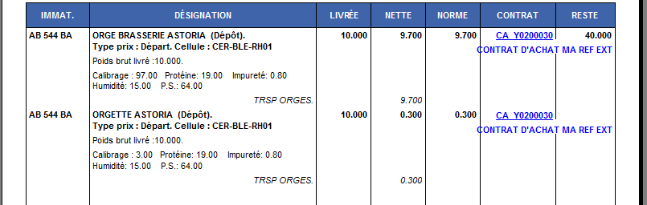

Version sans traits
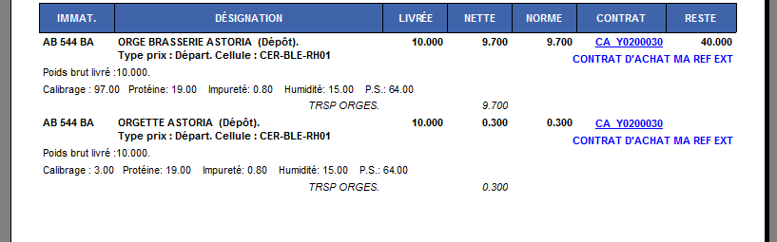

Version II
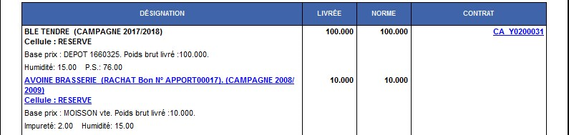
Tracedump:
newBaseSize: 16pt
newBaseSizeInPt: 16

